LECTURE NINE

9.1 Introduction
Welcome to the ninth lecture on operating systems. In this lecture we shall explore the topic of Input and Output (I/O) hardware and software.

9.2 Specific Objectives
At the end of this lecture you should be able to describe the following types of models
- Explore the structure of an operating system‘s I/O subsystem.
- Discuss the principles of I/O hardware and its complexity.

9.3 Lecturer Outline
9.3.1 I/O Hardware
9.3.2 Polling
9.3.4 Direct Memory Access
9.3.5 Device Controllers
9.3.6 Principles Of I/O Software
9.3.7 Clocks and Timers
9.3.8 Blocking and Non-blocking I/O
9.3.9 Kernel I/O Subsystem
9.3.10 Device drivers

9.3.1 I/O Hardware
Computers operate a great many kinds of devices. General types include
- storage devices (disks, tapes)
- transmission devices (network cards, modems)
- human-interface devices (screen, keyboard, mouse)
A device communicates with a computer system by sending signals over a cable or even through the air. The device communicates with the machine via a connection point termed a port e.g. a serial port. If one or more devices use a common set of wires, the connection is called a bus.
When device A has a cable that plugs into device B, and device B has a cable that plugs into device C, and device C plugs into a port on the computer, this arrangement is called a daisy chain. It usually operates as a bus.
A controller is a collection of electronics that can operate a port, a bus, or a device. A serial-port controller is an example of a simple device controller. It is a single chip in the computer that controls the signals on the wires of a serial port.
The SCSI bus controller is often implemented as a separate circuit board (a host adapter) that plugs into the computer. It typically contains a processor, microcode, and some private memory to enable it to process the SCSI protocol messages. Some devices have their own built-in controllers.
An I/O port typically consists of four registers, called the status, control, data-in, and data-out registers. The status register contains bits that can be read by the host. These bits indicate states such as whether the current command has completed, whether a byte is available to be read from the data-in register, and whether there has been a device error. The control register can be written by the host to start a command or to change the mode of a device. For instance, a certain bit in the control register of a serial port chooses between full-duplex and half-duplex communication, another enables parity checking, a third bit sets the word length to 7 or 8 bits, and other bits select one of the speeds supported by the serial port.
The data-in register is read by the host to get input, and the data out register is written by the host to send output. The data registers are typically 1 to 4 bytes. Some controllers have FIFO chips that can hold several bytes of input or output data to expand the capacity of the controller beyond the size of the data register. A FIFO chip can hold a small burst of data until the device or host is able to receive those data.

9.3.2 Polling
Incomplete protocol for interaction between the host and a controller can be intricate, but the basic handshaking notion is simple. The controller indicates its state through the busy bit in the status register. Remember that to set a bit means to write a 1 into the bit, and to clear a bit means to write a 0 into it. The controller sets the busy bit when it is busy working, and clears the busy bit when it is ready to accept the next command. The host signals its wishes via the command-ready bit in the command register. The host sets the command-ready bit when a command is available for the controller to execute.
For this example, the host writes output through a port, coordinating with the controller by handshaking as follows.

1. The host repeatedly reads the busy bit until that bit becomes clear.
2. The host sets the write bit in the command register and writes a byte into the data-out register.
3. The host sets the command-ready bit.
4. When the controller notices that the command-ready bit is set, it sets the Busy.
5. The controller reads the command register and sees the write command.
6. It reads the data-out register to get the byte, and does the I/O to the device.
7. The controller clears the command-ready bit, clears the error bit in the status register to indicate that the device I/O succeeded, and clears the busy bit to indicate that it is finished.

The host is busy-waiting or polling: It is in a loop, reading the status register over and over until the busy bit becomes clear. If the controller and device are fast, this method is a reasonable one. But if the wait may be long, the host should probably switch to another task

9.3.3 I/O Devices
Categories of I/O Devices include:
1. Human readable
2. machine readable
3. Communication
1. Human Readable is suitable for communicating with the computer user. Examples are printers, video display terminals, keyboard etc.
2. Machine Readable is suitable for communicating with electronic equipment. Examples are disk and tape drives, sensors, controllers and actuators.

Communication is suitable for communicating with remote devices. Examples are digital line drivers and modems.
9.3.3 .1 Differences between I/O Devices
1. Data rate: there may be differences of several orders of magnitude between the data transfer rates.
2. Application: Different devices have different use in the system.
3. Complexity of Control: A disk is much more complex whereas printer requires simple control interface.
4. Unit of transfer: Data may be transferred as a stream of bytes or characters or in larger blocks.
5. Data representation: Different data encoding schemes are used for different devices.
6. Error Conditions: The nature of errors differs widely from one device to another

9.3.4 Direct Memory Access
A special control unit may be provided to allow transfer of a block of data directly between an external device and the main memory, without continuous intervention by the processor. This approach is called Direct Memory Access (DMA). DMA can be used with either polling or interrupt software. DMA is particularly useful on devices like disks, where many bytes of information can be transferred in single I/O operations. When used in conjunction with an interrupt, the CPU is notified only after the entire block of data has been transferred. For each byte or word transferred, it must provide the memory address and all the bus signals that control the data transfer. Interaction with a device controller is managed through a device driver.
Device drivers are part of the operating system, but not necessarily part of the OS kernel. The operating system provides a simplified view of the device to user applications . In some cases, the operating system buffers data that are transferred between a device and a user space program (disk cache, network buffer). This usually increases performance, but not always.

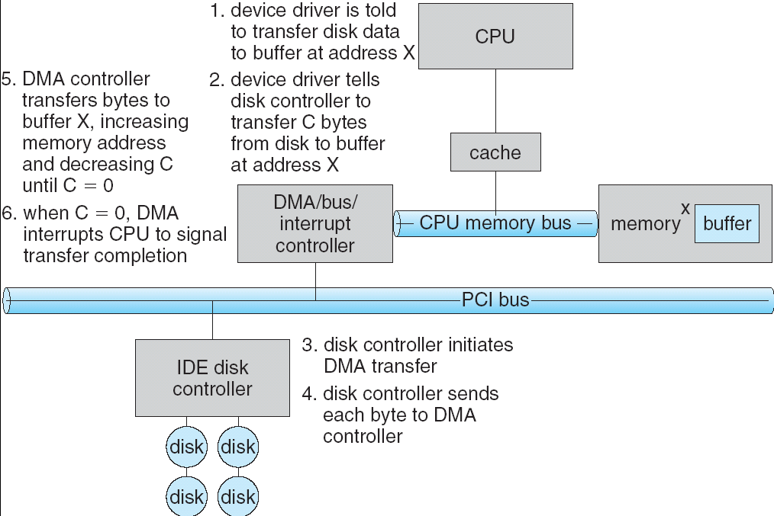

9.3.5 Device Controllers
A computer system contains a multitude of I/O devices and their respective controllers:
- network card
- graphics adapter
- disk controller
- DVD-ROM controller
- serial port
- USB
- sound card
9.3.6 Principles Of I/O Software
9.3.6.1 Interrupts
The CPU hardware has a wire called the interrupt request line that the CPU senses after executing every instruction. When the CPU detects that a controller has asserted a signal on the interrupt request line, the CPU saves a small amount of state, such as the current value of the instruction pointer, and jumps to the interrupt-handler routine at a fixed address in memory.
The interrupt handler determines the cause of the interrupt, performs the necessary processing, and executes a return from interrupt instruction to return the CPU to the execution state prior to the interrupt. We say that the device controller raises an interrupt by asserting a signal on the interrupt request line, the CPU catches the interrupt and dispatches to the interrupt handler, and the handler clears the interrupt by servicing the device.
This basic interrupt mechanism enables the CPU to respond to an asynchronous event, such as a device controller becoming ready for service. In a modern operating system, we need more sophisticated interrupt-handling features. First, we need the ability to defer interrupt handling during critical processing. Second, we need an efficient way to dispatch to the proper interrupt handler for a device, without first polling all the devices to see which one raised the interrupt. Third, we need multilevel interrupts, so that the operating system can distinguish between high- and low-priority interrupts, and can respond with the appropriate degree of urgency. In modern computer hardware, these three features are provided by the CPU and by the interrupt-controller hardware.
CPUs have two interrupt request lines. One is the non-maskable interrupt, which is reserved for events such as unrecoverable memory errors. The second interrupt line is maskable. It can be turned off by the CPU before the execution of critical instruction sequences that must not be interrupted. The maskable interrupt is used by device controllers to request service. This address is an offset in a table called the interrupt vector. This vector contains the memory addresses of .specialized interrupt handlers. The purpose of a vectored interrupt mechanism is to reduce the need for a single interrupt handler to search all possible sources of interrupts to determine which one needs service. The interrupt mechanism also implements a system of interrupt priority levels. This mechanism enables the CPU to defer the handling of low-priority interrupts without masking off all interrupts, and makes it possible for a high-priority interrupt to preempt the execution of a low-priority interrupt.
The interrupt mechanism is also used to handle a wide variety of exceptions, such as dividing by zero, accessing a protected or nonexistent memory address, or attempting to execute a privileged instruction from user mode. A system call is a function that is called by an application to invoke a kernel service. The system call checks the arguments given by the application, builds a data structure to convey the arguments to the kernel, and then executes a special instruction called a software interrupt, or a trap.
Interrupts can also be used to manage the flow of control within the kernel. If the disks are to be used efficiently, we need to start the next I/O as soon as the previous one completes. Consequently, the kernel code that completes a disk read is implemented by a pair of interrupt handlers. The high-priority handler records the I/O status, clears the device interrupt, starts the next pending I/O, and raises a low-priority interrupt to complete the work. The corresponding handler completes the user level I/O by copying data from kernel buffers to the application space and then by calling the scheduler to place the application on the ready queue.

9.3.6.2 Application I/O Interfaced
Structuring techniques and interfaces for the operating system enable I/O devices to be treated in a standard, uniform way. For instance, how an application can open a file on a disk without knowing what kind of disk it is, and how new disks and other devices can be added to a computer without the operating system being disrupted. The actual differences are encapsulated in ken modules called device drivers mat internally are custom tailored to each device but that export one of the standard interfaces.
The purpose of the device-driver layer is to hide the differences among device controllers from the I/O subsystem of the kernel, much as the I/O system calls.
- Character-stream or block. A character-stream device transfers bytes one by one, whereas a block device transfers a block of bytes as a unit.
- Sequential or random-access. A sequential device transfers data in a fixed order that is determined by the device, whereas the user of a random-access device can instruct the device to seek to any of the available data storage locations.
- Synchronous or asynchronous. A synchronous device is one that performs data transfers with predictable response times. An asynchronous device exhibits irregular or unpredictable response times.
- Sharable or dedicated. A sharable device can be used concurrently by several processes or threads; a dedicated device cannot.
- Speed of operation. Device speeds range from a few bytes per second to a few gigabytes per second.
- Read-write, read only, or write only. Some devices perform both input and output, but others support only one data direction. For the purpose of application access, many of these differences are hidden by the operating system, and the devices are grouped into a few conventional types.
Operating systems also provide special system calls to access a few additional devices, such as a time-of-day clock and a timer. The performance and addressing characteristics of network I/O differ significantly from those of disk I/O, most operating systems provide a network I/O interface that is different from the read-write-seek interface used for disks.

9.3.7 Clocks and Timers
Most computers have hardware clocks and timers that provide three basic functions:
1. Give the current time
2. Give the elapsed time
3. Set a timer to trigger operation X at time T
These functions are used heavily by the operating system, and also by time sensitive applications. The hardware to measure elapsed time and to trigger operations is called a programmable interval timer.

9.3.8 Blocking and Non-blocking I/O
One remaining aspect of the system-call interface relates to the choice between blocking I/O and non-blocking (asynchronous) I/O. When an application calls a blocking system call, the execution of the application is suspended. The application is moved from the operating system's run queue to a wait queue.
After the system call completes, the application is moved back to the run queue, where it is eligible to resume execution, at which time it will receive the values returned by the system call.
Some user-level processes need non-blocking I/O.

9.3.9 Kernel I/O Subsystem
Kernels provide many services related to I/O. The services that we describe are I/O scheduling, buffering caching, spooling, device reservation, and error handling.
9.3.9.1 Scheduling
To schedule a set of I/O requests means to determine a good order in which to execute them. The order in which applications issue system calls rarely is the best choice. Scheduling can improve overall system performance, can share device access fairly among processes, and can reduce the average waiting time for I/O to complete. Operating-system developers implement scheduling by maintaining a queue of requests for each device. When an application issues a blocking I/O system call, the request is placed on the queue for that device. The I/O scheduler rearranges the order of the queue to improve the overall system efficiency and the average response time experienced by applications.
9.3.9.2 Buffering
A buffer is a memory area that stores data while they are transferred between two devices or between a device arid an application. Buffering is done for three reasons.
- One reason is to cope with a speed mismatch between the producer and consumer of a data stream.
- Second buffer while the first buffer is written to disk. A second use of buffering is to adapt between devices that have different data transfer sizes.
- A third use of buffering is to support copy semantics for application I/O.

9.3.9.3 Caching
A cache is region of fast memory that holds copies of data. Access to the cached copy is more efficient than access to the original. Caching and buffering are two distinct functions, but sometimes a region of memory can be used for both purposes.
9.3.9.4 Spooling and Device Reservation
A spool is a buffer that holds output for a device, such as a printer, that cannot accept interleaved data streams. The spooling system copies the queued spool files to the printer one at a time. In some operating systems, spooling is managed by a system daemon process. In other operating systems, it is handled by an in kernel thread.
9.3.9.4 Error Handling
An operating system that uses protected memory can guard against many kinds of hardware and application errors.

9.3.10 Device drivers
In computing, a device driver or software driver is a computer program allowing higher-level computer programs to interact with a hardware device.
A driver typically communicates with the device through the computer bus or communications subsystem to which the hardware connects. When a calling program invokes a routine in the driver, the driver issues commands to the device, once the device sends data back to the driver, the driver may invoke routines in the original calling program. Drivers are hardware-dependent and operating-system-specific.
They usually provide the interrupt handling required for any necessary asynchronous time-dependent hardware interface.

9.4 Self Test Questions
- Define and Explain Direct Memory Access?
- Explain device controllers?
- Explain concept of I/O Hardware?
- Explain application of I/O interface?
- Describe blocking and non blocking I/O?

9.6 Suggestion for further reading
        - Abraham Silberschatz, Greg Gagne, Peter Baer Galvin(2002):Operating System Concepts, Wiley
        - Andrew S. Tanenbaum , Modern Operating Systems 3 e, (c) 2008 Prentice-H
Notes Extracted from
        - Prof. Harsh Bhor,Prof. UdayRote,Prof. Umesh Shinde Operating Systems (K.J.S.I.E.I.T SION MUMBAI)
9.5 Summary
- The basic hardware elements involved in I/O buses, device controllers, and the device themselves. The work of moving data between devices and main memory is performed by the CPU as programmed I/O or is offloaded to a DMA controller. The kernel module that controls a device driver.
- The system call interface provided to applications is designed to handle several basic categories of hardware, including block devices, character devices, memory mapped files, network sockets, and programmed interval timers.
- The system calls usually block the processes that issue them, but non blocking and asynchronous calls are used by the kernel itself and by applications that must not sleep while waiting for an I/O operation to complete.
- The kernel‘s I/O subsystem provides numerous services. Among these are I/O scheduling, buffering, caching. Spooling, device reservation, and error handling.
- The system call interface provided to applications is designed to handle several basic categories of hardware, including block devices, character devices, memory mapped files, network sockets, and programmed interval timers.
- The system calls usually block the processes that issue them, but non-blocking and asynchronous calls are used by the kernel itself and by applications that must not sleep while waiting for an I/O operation to complete.
- The kernel‘s I/O subsystem provides numerous services. Among these are I/O scheduling, buffering, caching. Spooling, device reservation, and error handling. I/O system calls are costly in terms of CPU consumption because of the many layers of software between a physical device and an application.

